Math en Jeu / MathAmaze LaTeX File Format

QUESTION AND FEEDBACK SECTIONS

All questions start with %Begin and finish with %End. This will help to prevent errors from creeping in if LaTeX files are concatenated or split apart. All information within the file is preceded by a tag encoded as a LaTeX comment of the form %word. The tags below, in boldface, show the recognized tags. All other comments in the LaTeX file will be ignored, so comments like “%========…” can be used as separators for file organization purposes.

%Begin
[…Question Header Block (see below)…]
%Qtext ← Tag indicating question text is immediately below
[…text..] ← Question text in LaTeX format
%ChoiceA ←The ChoiceA and subsequent choice tags only appear for multiple choice questions
[…text..] ← Text of choice A (i.e. “(A)…”)
%ChoiceB
[…text..]
%ChoiceC
[…text..]
%ChoiceD
[…text..]
%ChoiceE ← Having up to eight choices should cover all contest exams (i.e. up to ChoiceH)
[…text..]
%Ftext ← Tag indicating feedback text is immediately below
[…text…] ← Feedback text
%End

The tags above must appear in the order shown, from %Begin to %End.

QUESTION HEADER BLOCK

- %Language
  - Takes on values: English or French
- %Source
  - Optional tag
  - Name of competition or group providing question (eg. “Cariboo College…”, “International Assoc. of Math and Logic Puzzles”).
  - It should always be %Source, even if the problem being included is being adapted rather than kept in original form.
- %Title
  - Name of this particular test paper/contest sheet, etc.
  - It may simply be a year or date if the contest sheet has no particular subheading beyond the contest name (eg. “Junior Preliminary 1978”, “2004”, “2003 April 12” {use YYYY-Month-DD format for full dates})
- %Question
  - Optional tag
  - The question number as listed on the original contest page (eg “12”, or “5(i)”)
- %Subject
  - The short form subject heading from the list of math subjects defined by the SMAC team
- %Category
  - The short form category heading from the list defined by the SMAC team
- %Type
  - Takes on values: MC – multiple choice, SA – short answer, TF – true/false
- %Choices
  - Number of multiple choice options and only valid if %Type is “MC”
  - Integer between 3 and 8 (I’ve never seen a MC test with >8 choices and we can’t fit too many letters across the bottom of the screen) inclusive
- %Answer
  - The correct answer to the question (eg 3.14 for a SA question)
  - For MC, the letter of the correct answer; for TF, just T or F
- %Creator
  - Name of person who created or transcribed the question from its source
- %Translator
  - Name of person who translated question if this is a translation (otherwise omit the whole tag)
- %Rdifficulty
  - An integer value from 1—35 inclusive encoding the difficulty of the question
  - Can be used as an alternative to the %Qdifficulty tag. Use one or the other—do not attempt to include both.
- %Qdifficulty
  - A list of 18 comma separated values that encode the difficulty of the question for a general audience plus each of the 17 math educational levels in Quebec (prim. 1—6; séc. 1—3, 4&5 CST,TS,TN; Cegep 1,2)
  - Can be used as an alternative to the %Rdifficulty tag. Use one or the other—do not attempt to include both.

Notes:
- Tags that have not been marked as optional are required.
- Although some examples above are shown with quotation marks around them, do not put quotes around the comment values in the TEX file.
- The 13 tags within the header block do not have to be specified in the order shown, but the %Choices tag must come after %Type MC.

EXAMPLES

%Begin
%Language English
%Source Cariboo College High School Mathematics competition
%Title Junior Preliminary Round 1978
%Question 12
%Subject arithmetic
%Category naturals
%Type MC
%Choices 5
%Answer A
%Creator Roger Kemp
%Rdifficulty 1
%Qtext
\scriptsize Source: Cariboo College High School Mathematics Contest \normalsize
1+1=? \\
%ChoiceA
(A) 2 \\
%ChoiceB
(B) 3 \\
%ChoiceC
(C) 4\\
%ChoiceD
(D) 5\\
%ChoiceE
(E) None of the above\\
%Ftext
\textbf{The correct answer is (A): 2} \\ Russell and Whitehead proved this, years ago! \\
%End

%Begin
%Language English
%Source Calgary Junior High School Mathematics Contest
%Title 2005
%Question A3
%Subject arithmetic
%Category reals
%Type SA
%Answer 3.14
%Creator Roger Kemp
%Qdifficulty 5,0,0,0,6,5,4,3,3,2,1,1,0,0,0,0,0,0
%Qtext
\scriptsize Source: Calgary Junior High School Mathematics Contest \normalsize
To 2 decimal places $\pi=? \\
%Ftext
\textbf{The correct answer is 3.14} \\Amazing, but true.
%End
Table 1: Question subject and category values
Subjects | Category | Category (description)
algebra | concepts | concepts
algebra | manipulations | algebraic manipulations
algebra | syst-eq | systems of equations
algebra | modelling | problem modelling
arithmetic | naturals | natural numbers
arithmetic | fractions | fractions, decimal numbers, and percentages
arithmetic | integers | integers
arithmetic | reals | real numbers (rationals and irrationals)
arithmetic | proportions | proportions
arithmetic | powers | powers, roots, and logarithms
logic | general | general
functions | concepts | concepts
functions | polynomials | polynomials of degree 0, 1, or 2
functions | absval | absolute value function
functions | rational | rational functions
functions | parts | functions defined by parts
functions | floor | greatest integer function (floor function)
functions | periodic | periodic functions (sine,cosine, tangent)
functions | exponential | exponential and logarithmic functions
geometry | length | length, perimeter, and circumference
geometry | area | area
geometry | angles | angles
geometry | triangles | triangles
geometry | quad | quadrilaterals
geometry | 3D | three-dimensional figures (surface area and volume)
geometry | projections | spaces (projections)
geometry | Heron | Heron's formula
geometry | pythagorus | pythagorean formula
probability | concepts | concepts
probability | counting | counting
probability | calculations | probability calculations
probability | expectedval | expected values and equity
probability | chance | chance
statistics | concepts | concepts
statistics | diagrams | diagrams and tables
statistics | tendency | measures of central tendency
statistics | variance | measures of variation (standard deviation, variance, ...)
statistics | chance | chance
statistics | correlation | correlation
Table 2: Rdifficulty rating scale versus grade level. The individual question difficulties range from 0—6, with 1=very easy question, 6=very hard question, and 0=an excluded question because it’s too easy or too hard for that grade level.

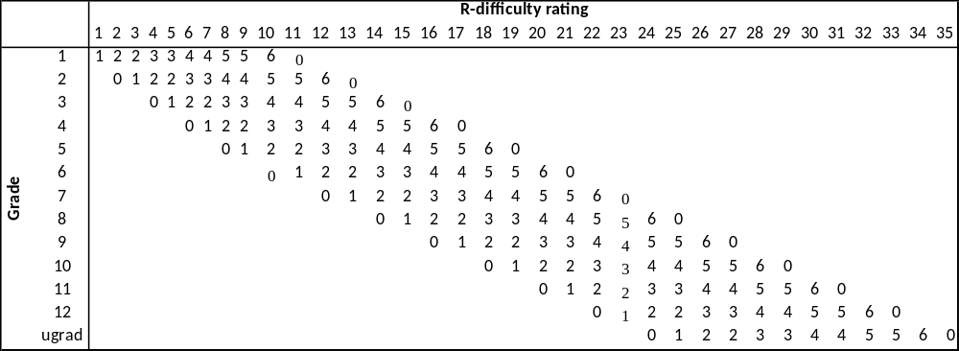

The tags are bolded in this document just for readability purposes. The TEX files are just flat text files and will contain no bolding.

